**MENU OF PRAVIN HOTEL KOZAPPALUR**

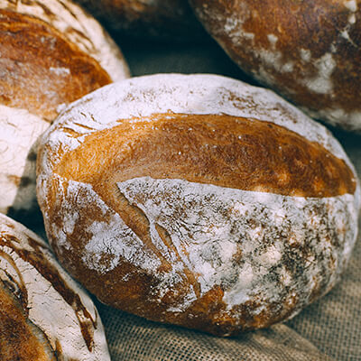

**BREAD BARREL**

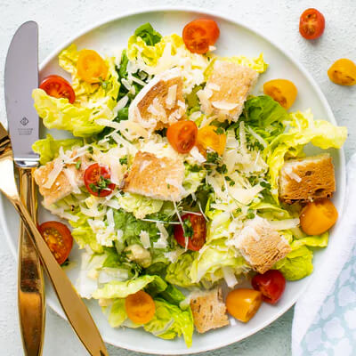

**CASEAR**



**CAKE**

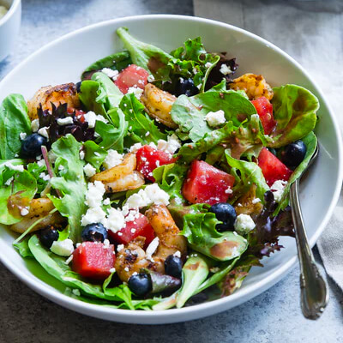

**GREEK-SALAD**

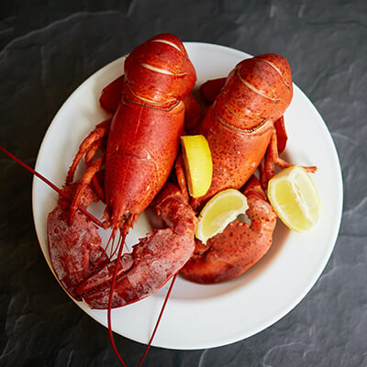

**LOBSTER-BISQUE**

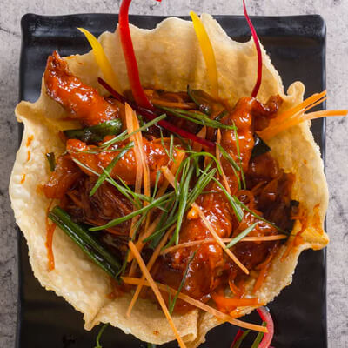

**LOBSTER-ROLL**

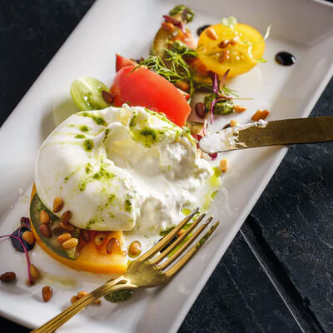

**MOZZERALLA**